**Dillon Hicks**

### 7/23/2018

Engineers for Exploration

**Orfeo Toolbox: Support Vector Machines**

## PREREQUISITES

Orfeo Toolbox 6.6.0

QGIS 6.6.0

## NOTES

# Introduction

Support Vector Machines (SVM’s) are a very powerful tool in image classification, and can be much more accurate than K-Means. SVM’s, as opposed to the unsupervised clustering of K-Means, are supervised, meaning that you already provide the labels and classes that the algorithm uses to classify pixels. With this, you can get much more accurate results with non arbitrary classes that you create.

However, training your SVM is much more computationally intensive than K-Means, as you both need to train the model, and run the clustering, as opposed to K-Means which clusters continuously. A standard SVM training takes from 1 hour to half a day, and the classification can take around the same amount of time. In addition, creating a SVM is more labor intensive, as you would need to manually label your examples.

To start, open QGIS and import your raster image by dragging the image from the File Explorer directly to the main screen of QGIS.

# 

# Labeling

Create a new vector layer by going to Layer and then Create layer and then click New Shapefile Layer...

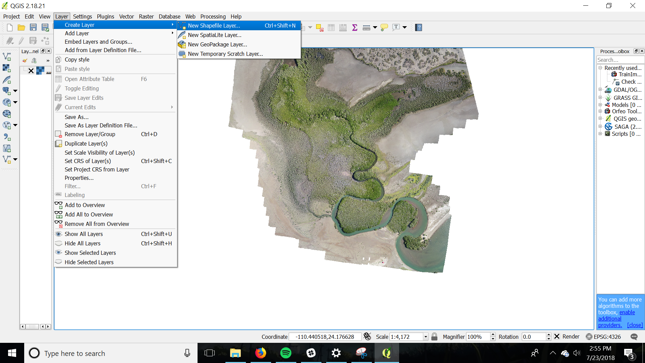

You should be taken to the following screen.

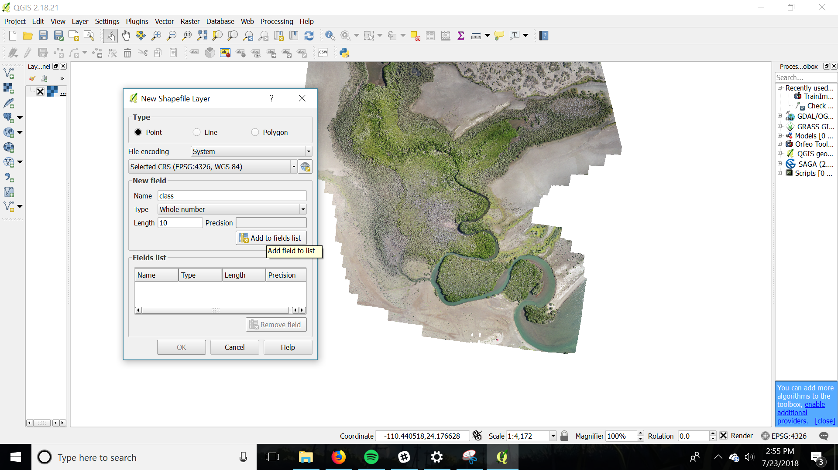

For type, select Polygon so that you can select regions that your specific classes belong to.

First, remove the id field by clicking on the field and then Remove field

Then, you can add a field that can store the class types by going in the New Field section and adding a field named class with type of a whole number (integer). If the amount of classes you want is above 10, you can increase this default number.

Click ok and then save the shapefile (you will use this file later)

Now you can start defining your classes by double clicking the vector layer you just created in the layer panel. This should open the layer properties panel, which you can add further options to your layer. Go to Style, and change the layer from Single symbol to Categorized.

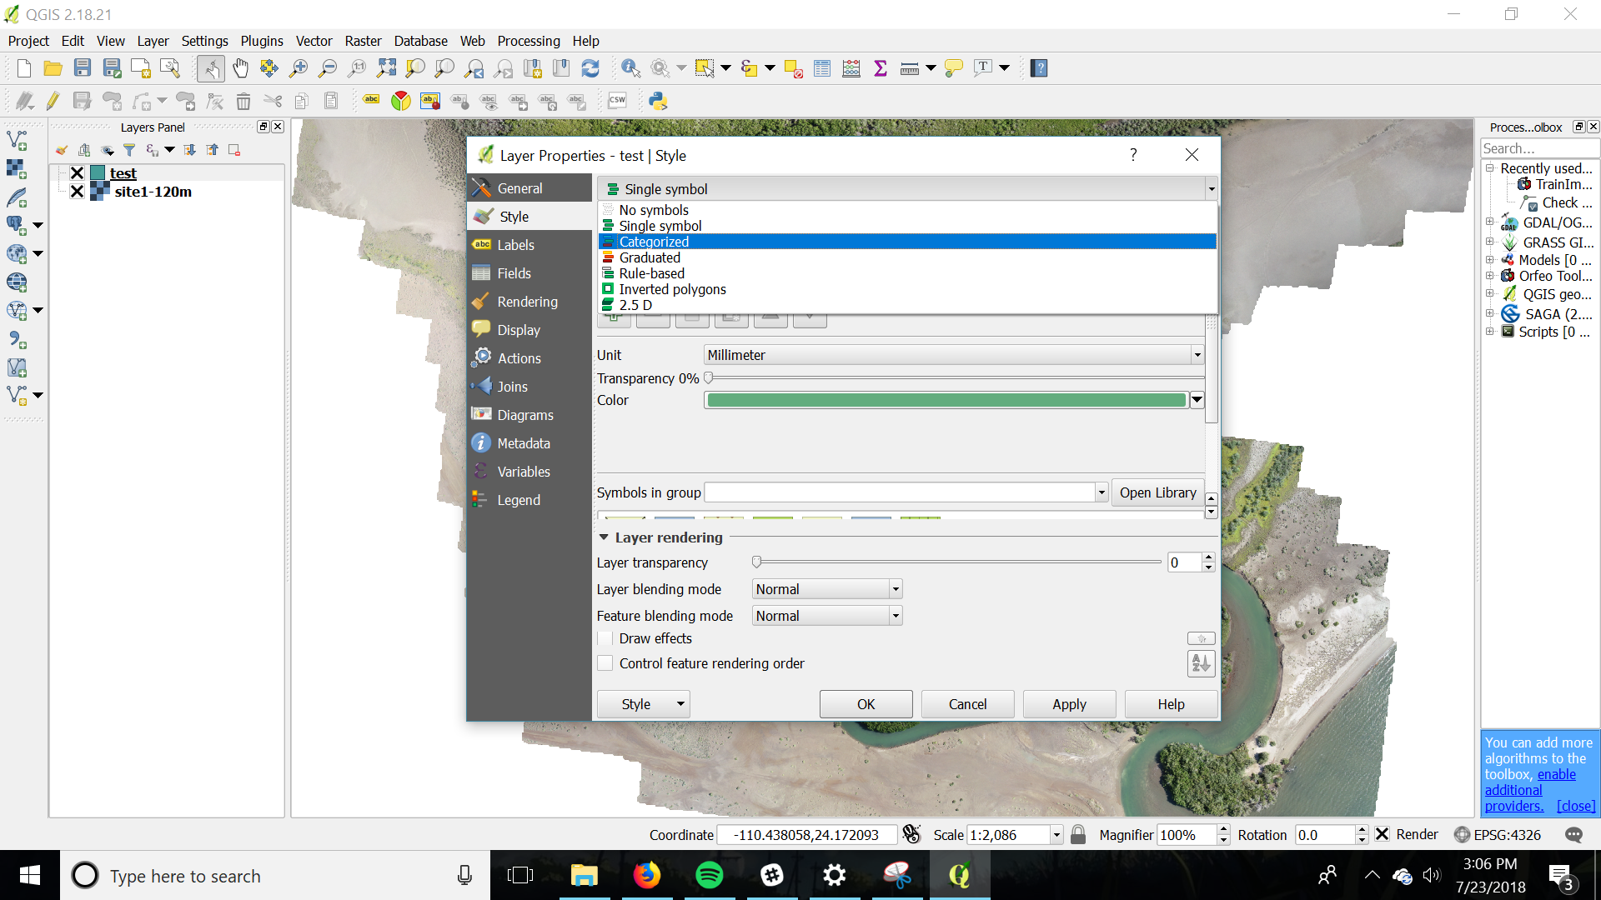

Click the plus icon to add more classes and change the classes according to you likes. Set each value for the class in the Value selection and the name of each class in the Legend section. A fully completed example below is shown.

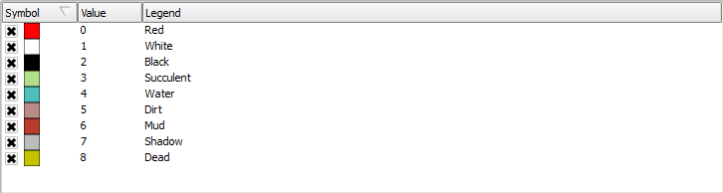

Click Apply and you should be back on the main screen of QGIS.

To start adding polygons, click Toggle Editing and then Add Feature. Start forming the polygons around you classes and right click to finish your polygon.

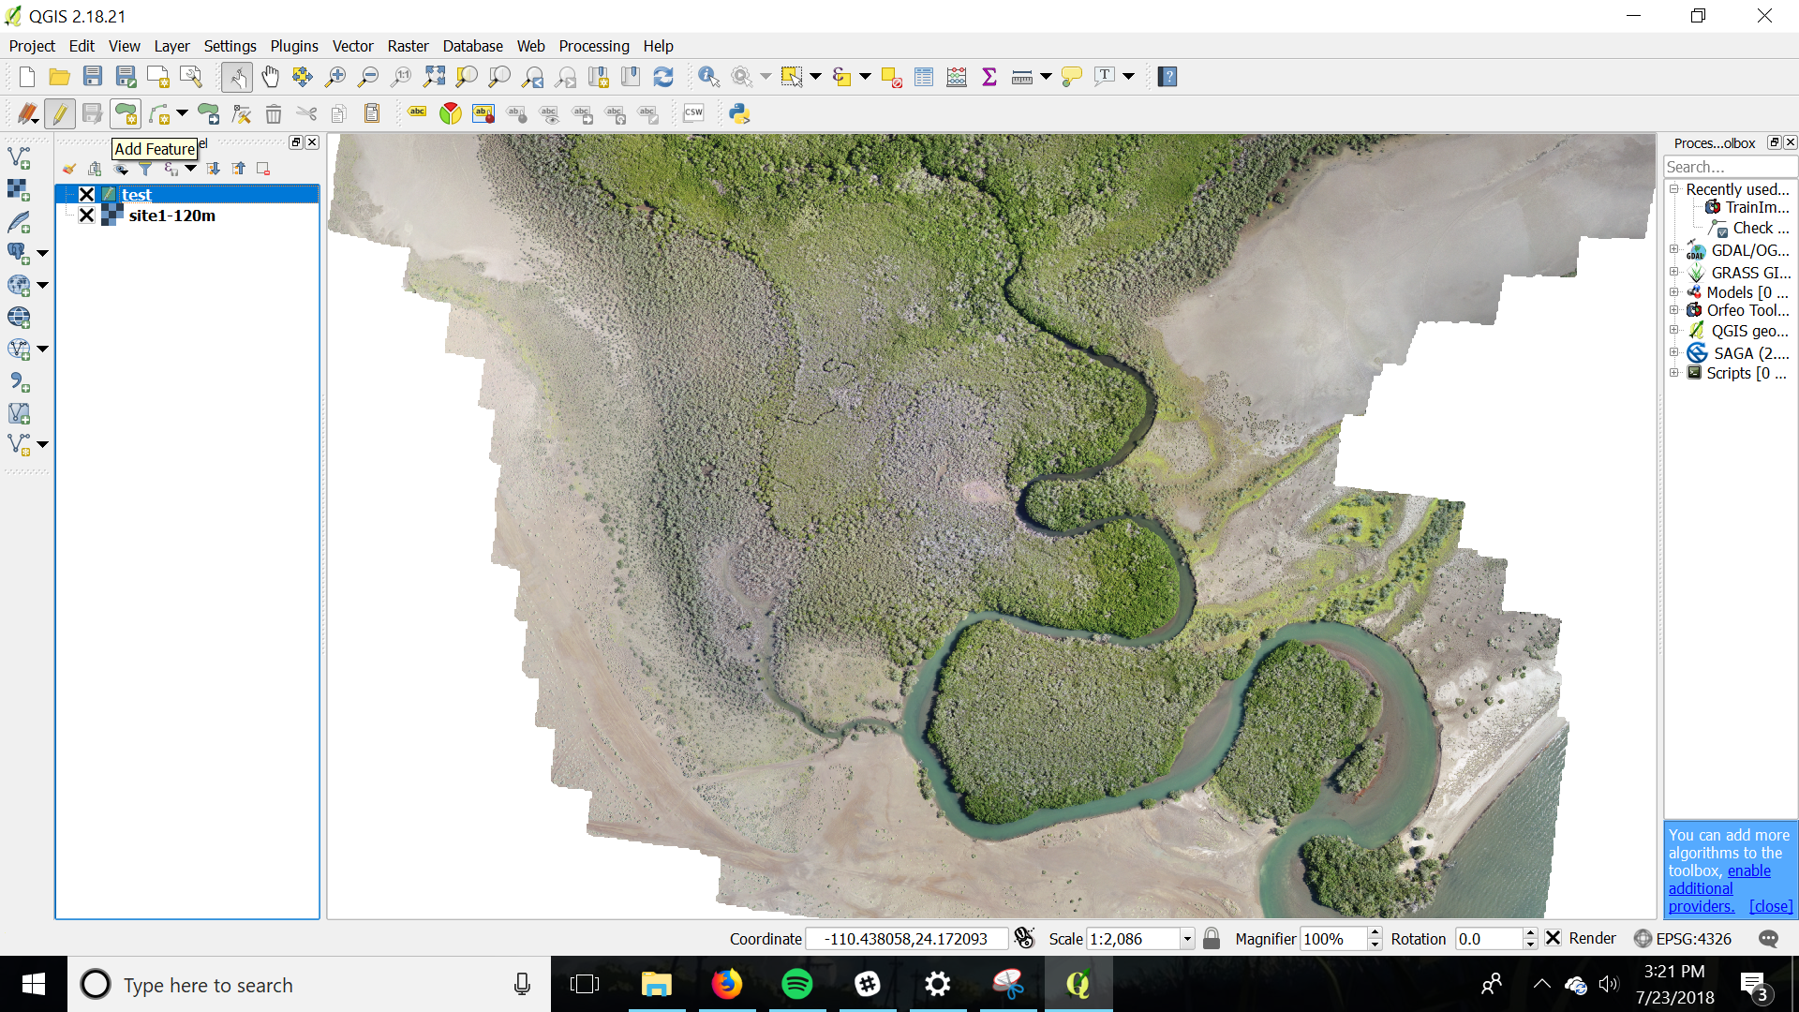

When the polygon is completed, enter the value of the class that you encompassed in the polygon and press OK.

In the example below, the finalized polygon is a red polygon in reference to the previous example.

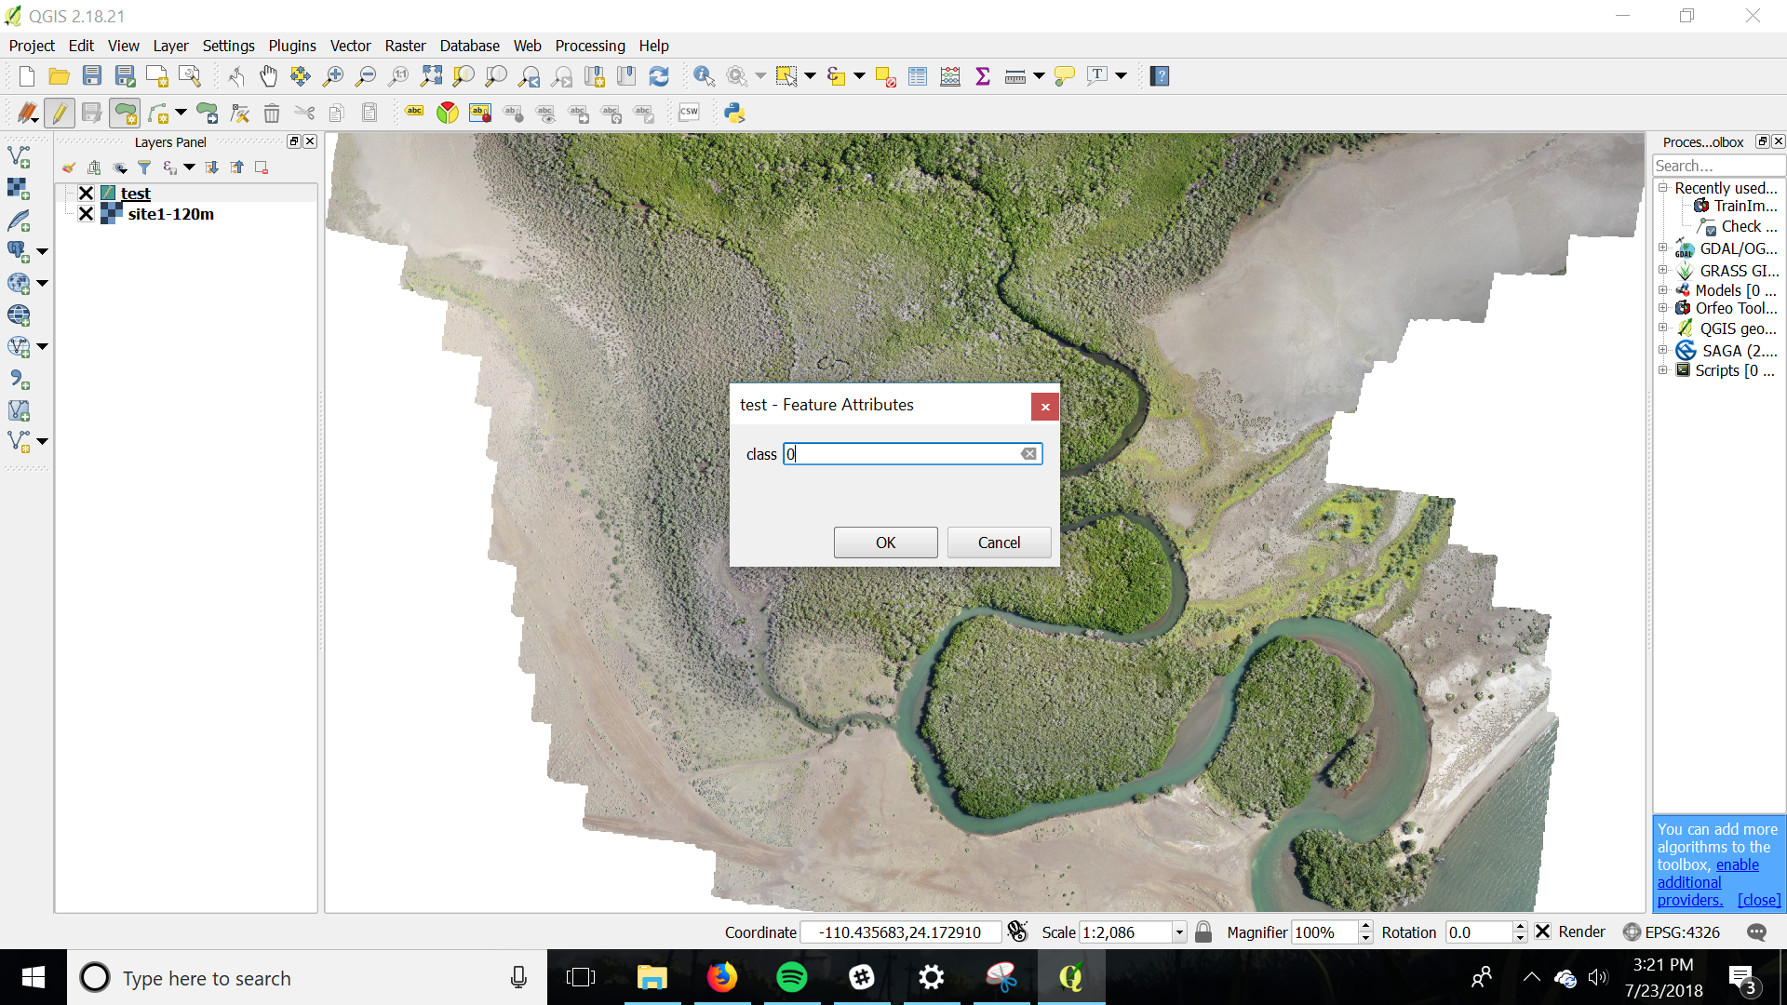

Here is an example of a fully classified region, with the different polygon regions representing different defined classes.

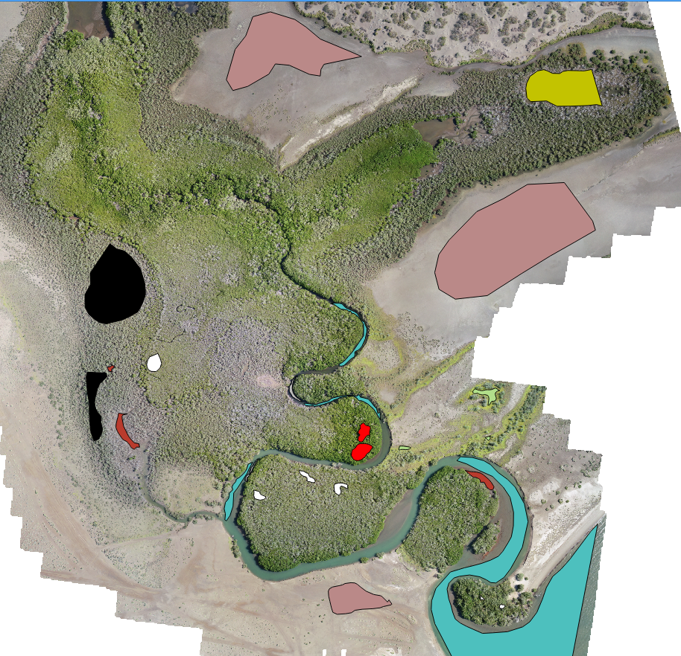

Now we can switch over to OTB to create the model and process the data.

# 

# 

# 

# Image Statistics (Optional but Recommended)

The first thing to do is to make an image statistics XML of your input image.

Open monteverdi and activate the OTB Applications browser either by clicking View and then OTB-Applications browser (or Ctrl-A).

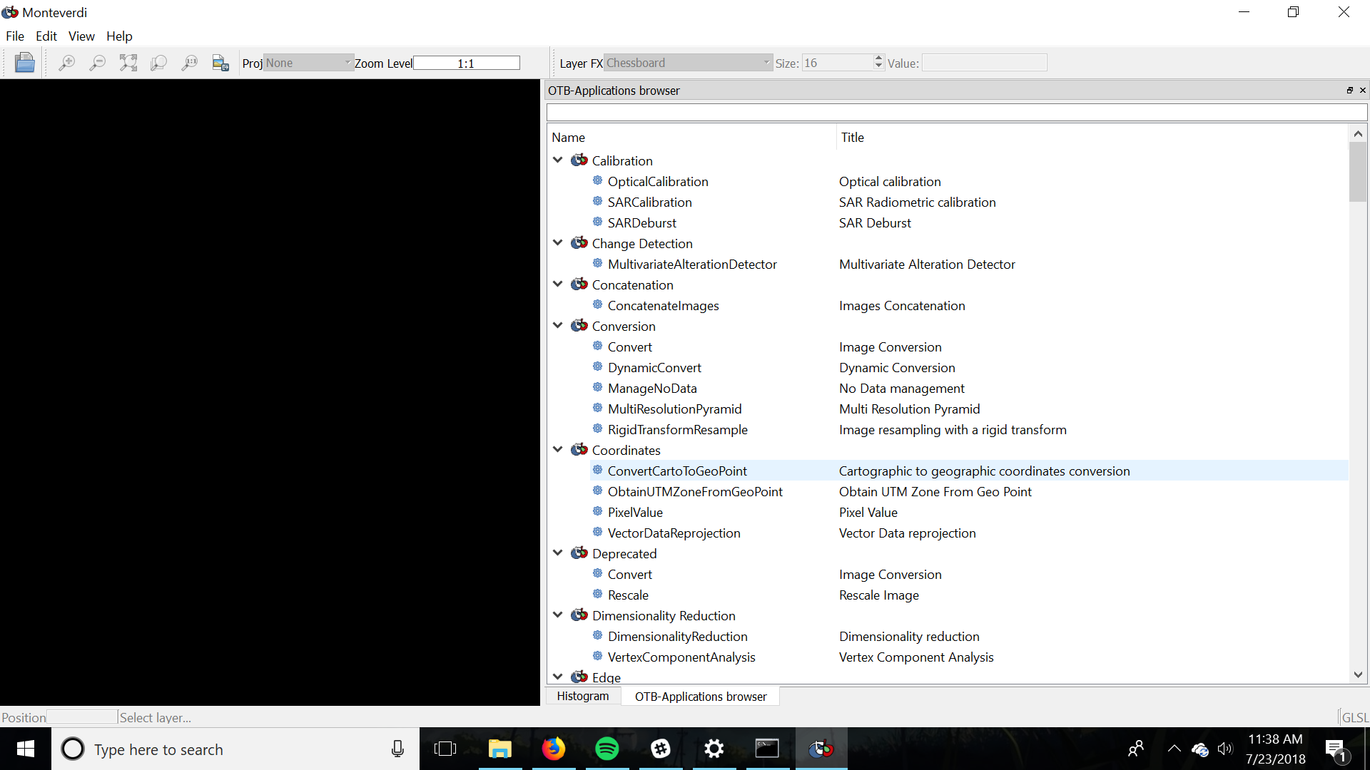

In Learning open Compute Image Statistics

Add your image using the + in the Input Images section.

Set the output XML file in the Output XML Section

Everything else can be kept as standard, if the file is exceptionally large you can increase the Available Ram (Mb) to improve the processing time, but most times the processing is very quick.

# Training

The training portion of this process is where you can use all of the files that you created.

While you still have Monteverdi open, go back to the OTB-Applications browser and go to Learning, and then to the TrainImagesClassifier.

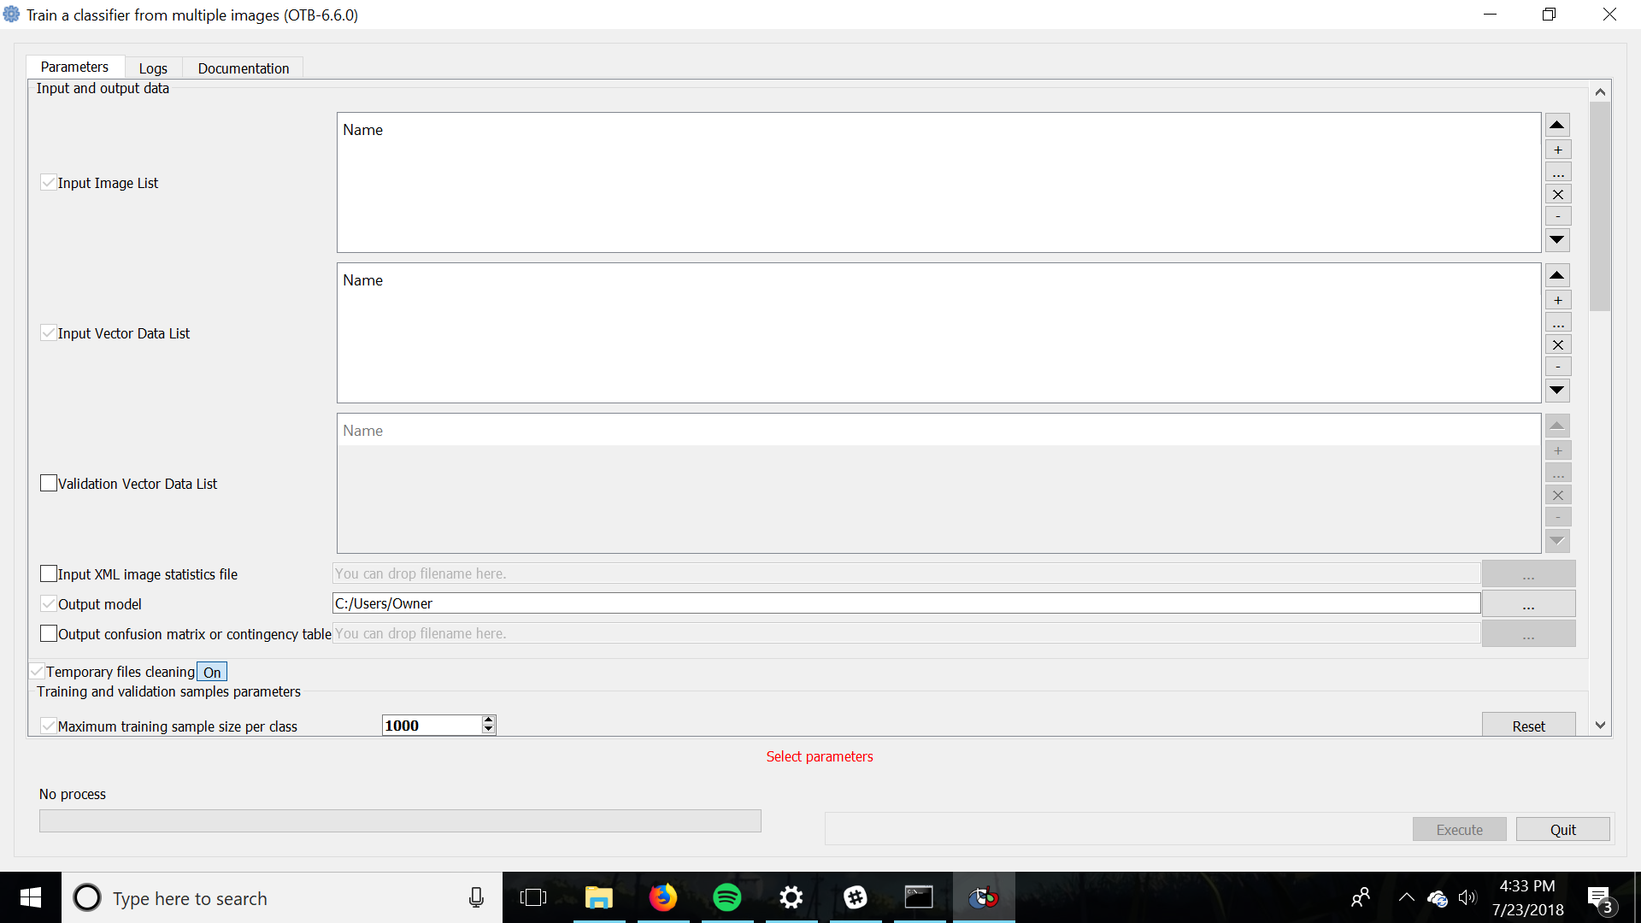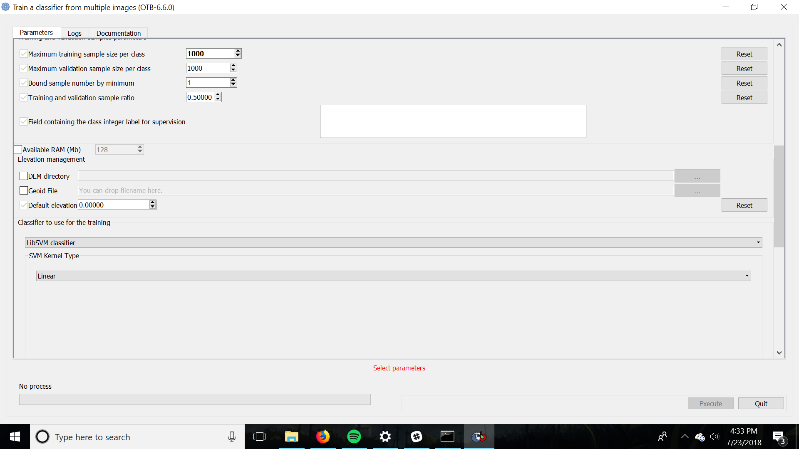

Add your input image in the Input Image List section

With the .SHP file created earlier that contains your polygon class information, add it using the Input Vector Data List section.

Add your image statistic file that you created earlier in the Input XML image statistics file section

In the Output model section select the location and name of the file that you want to write your SVM model to.

In Field containing the class integer label for supervision select the class field that you have previously recorded in QGIS.

For Available RAM (Mb) give essentially all that your computer can give. For example if your computer has 8GB of RAM make the available ram 8000, so don’t plan on doing anything but training on the computer that is running this processing.

In Classifier to use for the training select the LibSVM classifier with an SVM Kernel Type of Linear

Click on Execute and then prepare to wait a while, most likely at least an hour for your training to complete.

This will create the model file that you can use to classify your image in the next step.

# 

# 

# 

# 

# 

# 

# 

# Classification

Now that your model is done you can actually classify your image. This is the longest part of the process in terms of compute power needed, so be prepared to wait 24+ hours for the classification of large sites with many classes to complete.

To start the image classification go back to the OTB-Applications browser, and go to the Learning section and then start the ImageClassfier application.

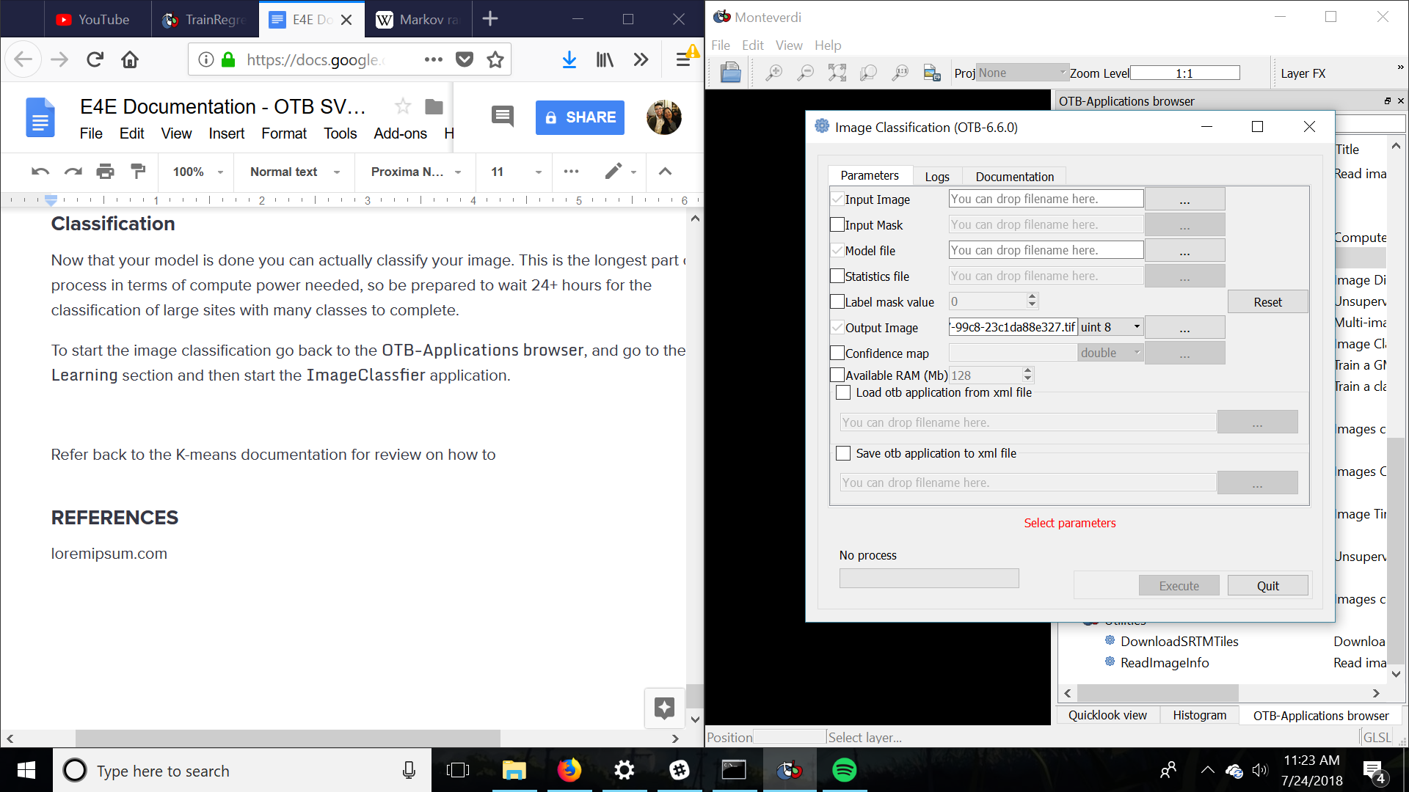

Select the original raster image that you created the ROI over for the Input Image section

For Model file select the model that you just generated in the section

If you have an image statistics XML, set this in Statistics file section

For the Output Image section select the location on your drive that you want the output classified image

Set the Available RAM (Mb) to the highest you can.

Afterwards you can then view the .tif file that has been created in QGIS and apply categorical color settings to view it according to the classes that you create.

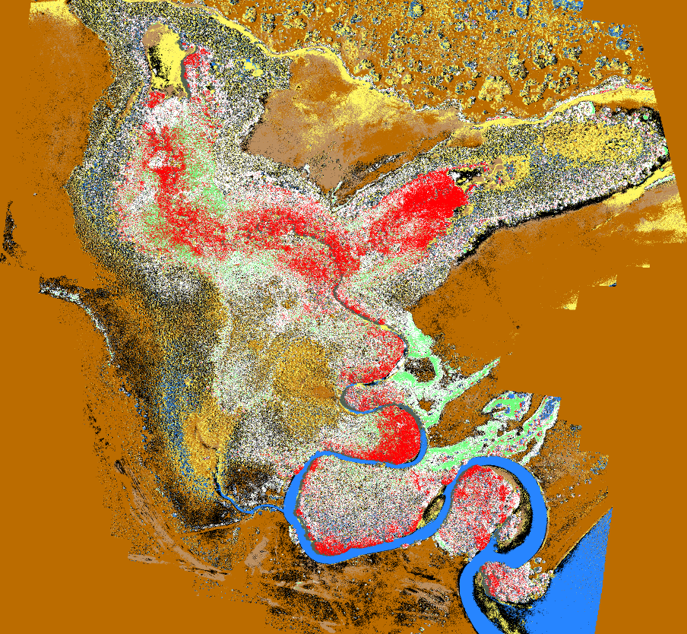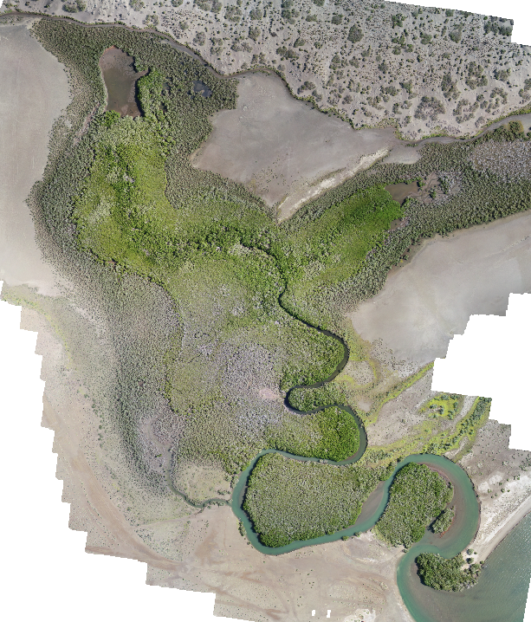

Here is the resultant classification on the left with the original on the right.

Refer back to the K-means documentation for a review on how to apply the sieve to get a less noisy image.

# REFERENCES

QGIS Documentation

https://docs.qgis.org/2.8/en/docs/index.html#

GDAL Documentation

https://trac.osgeo.org/gdal/

Orfeo Toolbox Documentation

https://www.orfeo-toolbox.org/documentation/